eSign Documents – Orientation Guide (Sample)

This sample eSign Document Orientation Guide was graciously provided by one of our eSign customers to share as a resource to help other teams get started with eSign.

If this helps, please feel free to use and modify to meet your needs.

Contact the eSign Team us at support@esign-app.com for assistance.

This guide provides step-by-step instructions on how to initiate a formal document review and approval process using the eSign Document Management & Training (eDoc) app in Atlassian Confluence.
The numbered steps in this guide align with the corresponding numbers in the screenshots for reference.

For Document Owners

Initiating the Review
1. Open the relevant Confluence page (Working Copy/Draft) and click on eSign Document in the byline
Note:
- Sub-pages are specific approved revisions ("Release Copies") and are not be edited or updated.
- If a sub-page does not exist, it means the document hasn't gone through an eDoc approval cycle yet—use the Working Copy to review or create a new version.
When preparing for the next review or updating a document using eDoc, always edit the Working Copy, for example, CD034(02) Cloud Services Policy.
Why? All editing, reviewing, and approvals take place on the working copy. The "release copy" is simply a read-only snapshot of a specific approved revision.
2. In the eDoc dialog box, click Start Document to begin the review process.

Start Document vs New Revision

Note:
The Start Document applies only when converting a Confluence page into a Working Copy. Users then draft, review, and approve revisions within the Working Copy.
The New Revision button is on the Closed tab of the Working Copy, which should be displayed by default for anyone that views it: screenshot below.
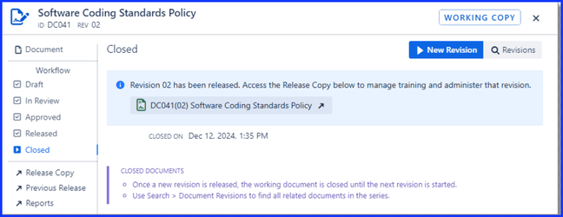
3. Choose the Document Type as "Controlled Document". Leave other fields as default.
4. Check that the Owner has your name by default. You may also add other owners if applicable.
5. Click Start to initialize the document.
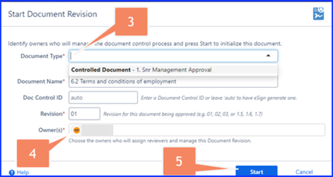
The owner is the person or people listed in the “Owners” field within eDoc. Multiple owners can be assigned. This is set when the document is “Started.” Owners are responsible for guiding the document through the review and approval process, and are typically the individuals who initiate it.
Note: This is not the same as the “Owner” shown on the Confluence page itself - there is no connection between the two.

Assign Reviewers
6. Click Assign Reviewers to select the reviewers and initiate the review.
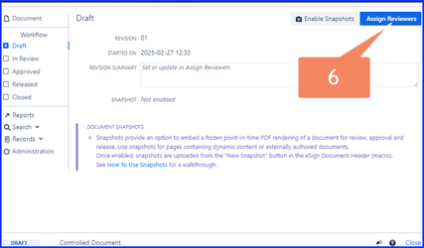
7. Select a Reviewer name for each required Review slot.
8. Enter the Revision Summary
Important Note: This is a formal text that will become part of the document revision history. It serves a similar purpose to the Version History comments in traditional Word documents, so ensure it accurately reflects the changes made. It can be edited during the review process by returning to the Assign Reviewers screen.
9. Click Submit.

Document Reviews: Next Steps After Approvals and Rejections
Reviewers will receive an email notification with a link to the document.
- If the reviewer approves the revision, the document is approved and moves forward in the workflow.
If the reviewer rejects the revision, they will provide feedback, and the document owner(s) will receive email notifications of the rejection.
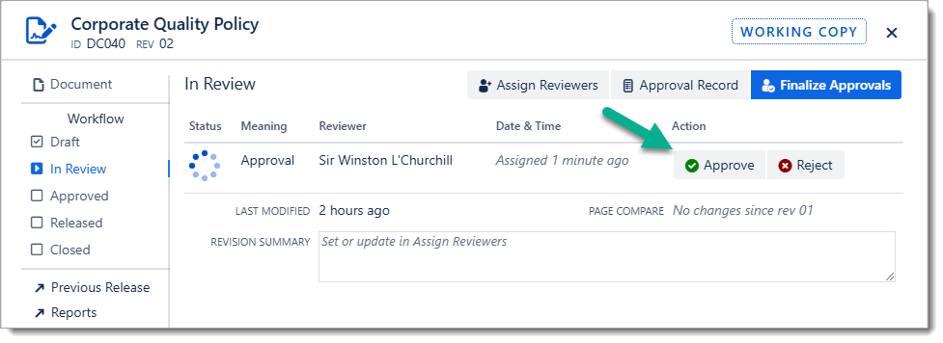

Handling Document Rejections
- Reviewer rejects the document and leaves feedback
- the document owner/author will receive an email notification.
- Author edits the document directly.
- When ready for re-review, there are two options:
Option A
Contact the reviewer directly and request they re-check the document.
  - The reviewer can then choose "Approve" from the (...) menu on their previous rejection comment.
(Recommended for complex changes needing discussion.)
Option B
The document owner/author "Reopens" the rejected review, automatically notifying the reviewer by email.
  - The reviewer then reviews the updated document and selects "Approve" if satisfied.

Check PENDING APPROVALS - who is holding this up?
- Access the eSign Document Search Page:
  - Click on the top menu in Confluence.
  - Navigate to Apps > eSign Documents.
- Filter for Pending Approvals:
  - Select the APPROVAL view (#1) to display only active working copies (e.g., DRAFT, IN REVIEW).
  - The Pending Reviewers column will identify which users have incomplete reviews.
  - Gently nudge the Reviewer
    - If they are absent from work you can reassign another reviewer to approve the document. How? Just go back to the eSign document and Assign Reviewer. Go on.
- Optional: Filter by Reviewer Role:
  - Under My Role (#2), select Reviewer to see only the documents where you are assigned as a Reviewer.

How to Manage Document Revisions
- Once a Document Revision is approved/released it is read-only. To update the document in the future, go to the Working Copy and click Start New Revision.
- Repeat the review and approval process.
- Older released revisions remain accessible but are marked as obsolete.

Accessing Archived Revisions
- Obsolete documents are automatically archived.
- Archived revisions can be found in Space Settings > Content > Archived, where you can view or restore them if needed. Space admin access may be needed to view archived document revisions.
This ensures that older versions are retained while keeping the active document list clean.

Document Status Indicator
- Navigate to the Confluence page in question.
- Look for the eSign Document Header at the top of the page, which displays the document's status.
- If the status is labeled as "Working Copy", it indicates that this is the editable version of the document.
Here's a legend of the document status lifecycle

Working Copy
- Draft: The initial stage where the document is being created or edited and has not yet been submitted for formal review.
- In Review: The document has been submitted for review/approval and is awaiting feedback or approval (signatures) from designated reviewers.
- Approved: All assigned reviewers have provided their approval signatures, indicating the document meets the necessary standards.
- Closed: After the current Document Revision is released the working copy is inactive but remains available for future revisions. The document stays in this state until a new revision cycle begins.
- Draft (Next Revision)

Release Copy
- Released: The approved document is officially published and made accessible to the intended audience.
- Obsolete: The document is no longer in active use, usually because it has been replaced by a newer version. It is retained for historical reference.
Note: You may need to refresh the Confluence page to display the correct status.

For Reviewers

Reviewing & Approving Documents
- You’ll receive email notifications and can approve or reject the document within Confluence.
- If rejected, please provide feedback to the page owner for necessary revisions.
- Once all reviewers have approved, the document is finalized.

For Document Admins

Release the Document
- After final approval, release the document revision to make it accessible. This is called publishing the document.
- The system creates a new Confluence page that is a read-only copy of the approved working copy.
- A PDF of the Approval Record is attached for audit purposes.

